CSA0502 – QUERY PROCESSING FOR DATASCIENCE
Lab Programs
9. Pivot Table – Total Sale Amount Region-wise, Manager-wise, Salesman-wise
Aim
To create a Pivot Table and find the total sale amount region-wise, manager-wise, and salesman-wise.
Code
import pandas as pd

# Create Dataset
data = {
"Region": ["East", "East", "West", "West", "North", "South"],
"Manager": ["John", "John", "David", "David", "Peter", "Mary"],
"Salesman": ["A", "B", "C", "D", "E", "F"],
"Sale": [5000, 7000, 6000, 8000, 9000, 7500]
}

df = pd.DataFrame(data)

print("Original Dataset")
print(df)

# Pivot Table
pivot = pd.pivot_table(
df,
values="Sale",
index=["Region", "Manager", "Salesman"],
aggfunc="sum"
)

print("\nPivot Table")
print(pivot)

Output
Original Dataset

Region Manager Salesman Sale
0 East John A 5000
1 East John B 7000
2 West David C 6000
3 West David D 8000
4 North Peter E 9000
5 South Mary F 7500

Pivot Table

Sale
Region Manager Salesman
East John A 5000
B 7000
North Peter E 9000
South Mary F 7500
West David C 6000
D 8000
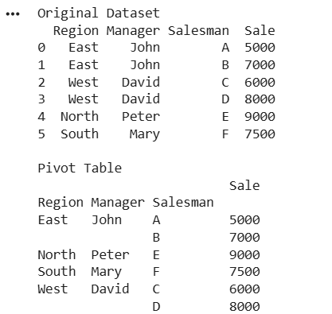
Result
The Pivot Table showing the total sale amount region-wise, manager-wise, and salesman-wise was created successfully.
10. Highlight Negative Numbers
Aim
To create a DataFrame with random values and highlight negative numbers in red and positive numbers in black.
Code
import pandas as pd
import numpy as np

df = pd.DataFrame(
np.random.randint(-20, 20, (10, 4)),
columns=["A", "B", "C", "D"]
)

print(df)

def color_negative(val):
if val < 0:
return "color:red"
else:
return "color:black"

df.style.map(color_negative)
Output
A B C D
0 -5 6 12 -8
1 9 -3 15 7
2 10 11 -2 5
...
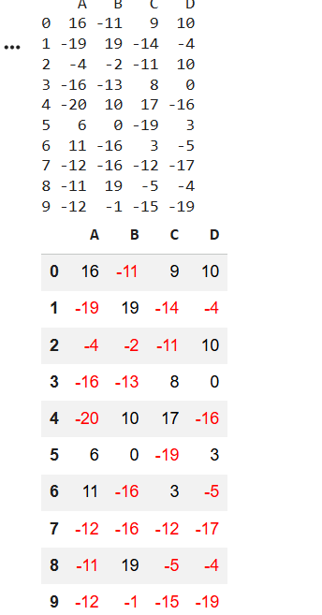
Result
The DataFrame was created successfully, and negative values were highlighted in red while positive values were displayed in black.

